Application Number | 07/2019/7007/HOH
Address | 327 Dunkirk Lane  Moss Side  Leyland  Lancashire  PR26 7SY
Applicant | Mr Liam Derbyshire
Agent | Mr Neil Sharp
20 Kenford Drive
Winstanley
Wigan
WN3 6JW
Development | Erection of detached double garage to font
Officer Recommendation | Approval with Conditions
Officer Name | Mrs Catherine Lewis
Date application valid | 17.07.2019
Target Determination Date | 11.09.2019
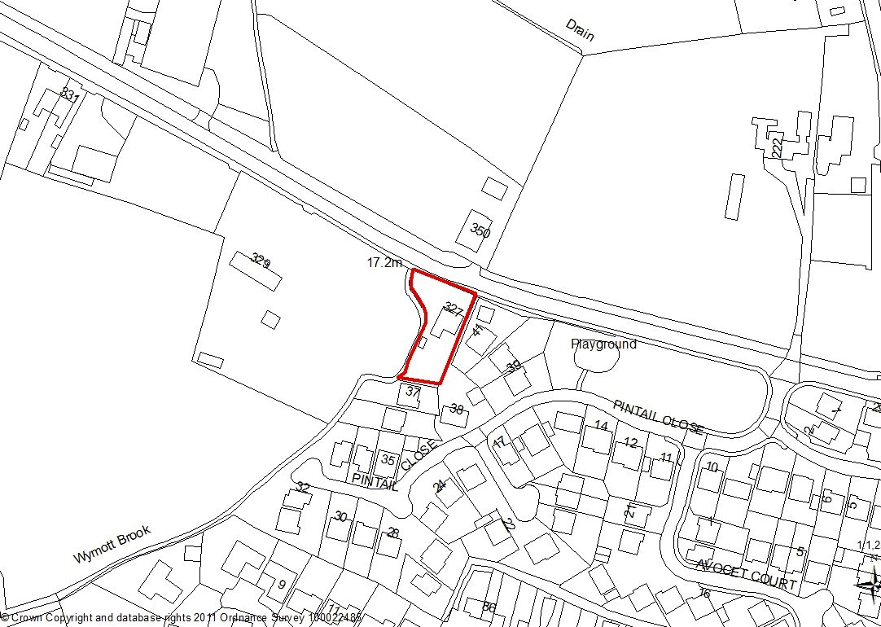

1. Introduction
1.1. The size and nature of this application would normally fall under the scheme of delegation but as the applicant is related to a member of the Council, the application is now before you.

2. Report Summary
2.1 The application relates to the erection of a detached double garage. The scheme has been assessed against current planning policies including the national planning policy framework and the development plan policies and is recommended for approval.

3. Site and Surrounding Area
3.1 The application site is located approximately 3km west of Leyland town centre and is situated in a plot with an area of approximately 0.19 of an acre. Wymott Brook forms the western boundary with the Green Belt beyond. Access to the site is from Dunkirk Lane which forms the northern boundary and residential housing lies the south and east boundaries.
3.2 The site is located within the existing built up boundary as defined by Policy B1 Existing built up boundary.

4. Site History
4.1 07/2016/0362/FUL Erection of one detached dwelling and double garage following demolition of existing bungalow and garage. Withdrawn
4.2 07/2016/0714/FUL Erection of one detached dwelling following demolition of existing bungalow and garage. Approved October 2016
4.3 07/2016/1049/DIS Application to discharge conditions 3 (Desk study - Contamination) 6 (Surface water) 10 (Dwelling emission rate) 11 (Dwelling.
4.4 07/2016/1359/HOH Erection of a Detached Double Garage. Replacement of existing Hedgerows with Boundary Brick Wall and railings. Withdrawn
4.5 07/2019/2266/HOH Erection of 1.6m high (max) garden wall with new access gates to
With new access gates to front. Approved April 2019.

5. Proposal
5.1 Planning permission is sought for the construction of detached double garage measuring6.4m x 5.2m with a height to eaves of 2.2m and a maximum height to the ridge of 3.6m. The garage would be constructed of render with a concrete tile to match the dwelling.

6. Summary of Publicity
6.1 Neighbouring residents have been notified with no letters of representation being received.

7. Summary of Consultations
7.1 LCC Highways: No objection
7.2 Environment Agency: No objection subject to an Informative about the need for the applicant to contact them in case an Environmental Permit is required for any of the proposed works.
8.0 Policy Background

Core Strategy
Policy 17: Design of New Buildings expects the design and new buildings to take account of the character and appearance of the local area; be sympathetic to surrounding land uses and occupiers; ensure that the amenities of occupiers of the new development will not be adversely affected by neighbouring uses and vice versa; minimise opportunity for crime; provide landscaping as an integral part of the development, protecting existing landscape features and natural assets, habitat creation, provide open space and enhance the public realm; be adaptable to climate change and adopt the principles of sustainable construction including sustainable drainage systems and ensure that contaminated land is addressed through appropriate remediation and mitigation measures.
Policy 22: Biodiversity and Geodiversity seeks to conserve, protect, enhance and manage the biological and geological assets of an area.
Policy 29: Water Management seeks to improve water quality and reduce flooding
Policy G13: Trees, Woodlands & Development has a presumption in favour of the retention and enhancement of existing tree, woodland and hedgerow cover on site.
Policy G16: Biodiversity & Nature Conservation seeks to protect, conserve and enhance the borough’s biodiversity and ecological network resources.

South Ribble Local Plan
Policy G13: Trees, Woodlands & Development has a presumption in favour of the retention and enhancement of existing tree, woodland and hedgerow cover on site.
Policy G16: Biodiversity & Nature Conservation seeks to protect, conserve and enhance the borough’s biodiversity and ecological network resources
Policy G17: Design Criteria for New Development permits new development provided that the development does not have a detrimental impact on neighbouring buildings or on the street scene by virtue of its design, height, scale, orientation, plot density, massing, proximity, use of materials. In addition any new roads and/or pavements provided as part of the development should be to an adoptable standard; and the proposal would not have a detrimental impact on landscape features such as mature trees, hedgerows, ponds and watercourses.

9. Material Considerations
9.1 The site is allocated under Policy B1 of the South Ribble Local Plan – existing settlements and is a newly constructed residential property. This particular property although located on the very edge of the urban boundary adjacent to the Green Belt is a modern design and is constructed of white render. The plot is also adjacent to the recent housing estate known as Pintail Close but due to the different access arrangements the application site faces and is accessed directly from Dunkirk Lane.
9.2 When considered in context, and viewed from Dunkirk Lane, the application site boundary has a rural appearance with strong countryside hedging to the front boundary, and trees to the western boundary adjacent to the River Wymott. Planning permission has recently been approved to provide for a 1.6m high (max) garden wall with new access gates. This would be constructed of part render to be white in colour with black railings on top. A landscaping scheme has been approved as part of this application which would provide for a hedge between the wall and the back of the pavement with additional tree planting to the western boundary.
9.3 The proposed garage located behind the previously approved wall and gates, would be constructed of materials of white render and concrete tiles and would complement the newly constructed property. The previously approved landscaping plan would soften the impact of the boundary treatment and will continue to provide foraging opportunities for the local wild life. Therefore, the proposal is considered acceptable and meets the aims of Policies G16 and G17 of the South Ribble Local Plan.
9.4 The nearest residential property is located approximately 12 metres away on the opposite (northern) side of Dunkirk Lane. As planning permission has already been granted for the wall and the gates, it is considered that the garage would not have an undue impact upon residential amenity and therefore meets the aims of Policy G17 of the South Ribble Local Plan.

9.5 Suitability of Access
9.6 LCC Highways has raised no objection to the garage having previously considered and found acceptable the boundary wall and access gates. Therefore the scheme is acceptable and complies with Policy G17 of the South Ribble Local Plan.

9.7 Drainage and Ground Levels
9.8 The application site lies within Flood Zone 3 which is defined as having a high probability of flooding as the site is adjacent to the River Wymott. The Environment Agency has raised no objection but has requested that an Informative is include on any Decision Notice to advise the applicant to contact the EA about the need for an Environmental Permit.

10 CONCLUSION
The application site is located approximately 3km west of Leyland town centre and consists of a recently constructed large detached dwelling and new boundary treatment. The scheme has been assessed against the Development plan and the NPPF and the proposed garage is considered acceptable and is recommended for approval.

RECOMMENDATION:

Approval with Conditions.

RECOMMENDED CONDITIONS:

1. The development hereby permitted must be begun not later than the expiration of three years beginning with the date of this permission.
REASON: Required to be imposed pursuant to Section 91 of the Town and Country Planning Act 1990.

2. The development, hereby permitted, shall be carried out in accordance with the submitted approved plans:
Drawing No. DL-02 entitled Site Location Plan
Drawing No. DL-14 entitled Proposed Garage

REASON: For the avoidance of doubt and to ensure a satisfactory standard of development.

3. All external facing materials shall match in colour, form and texture to those on the existing building.
REASON: In the interests of the visual amenity of the area and so that the Local Planning Authority shall be satisfied as to the details in accordance with Policy 17 in the Central Lancashire Core Strategy and Policy G17 in the South Ribble Local Plan 2012-2026

RELEVANT POLICY

NPPF National Planning Policy Framework

17 Design of New Buildings (Core Strategy Policy)

22 Biodiversity and Geodiversity (Core Strategy Policy)

29 Water Management (Core Strategy Policy)

POLB1 Existing Built-Up Areas

POLG13 Trees, Woodlands and Development

POLG16 Biodiversity and Nature Conservation

POLG17 Design Criteria for New Development

Note:
The applicant is advised to contact the Environment Agency as the development is within 8metres of a Main River and An Environmental Permit will be required. For further guidance please visit https://www.gov.uk/guidance/flood-risk-activitiesenvironmental- permits or contact our National Customer Contact Centre on 03702 422 549.

